CHIJ STC
Sec 2 Subject Combination Exercise

URL : https://stc.schoolhub.sg

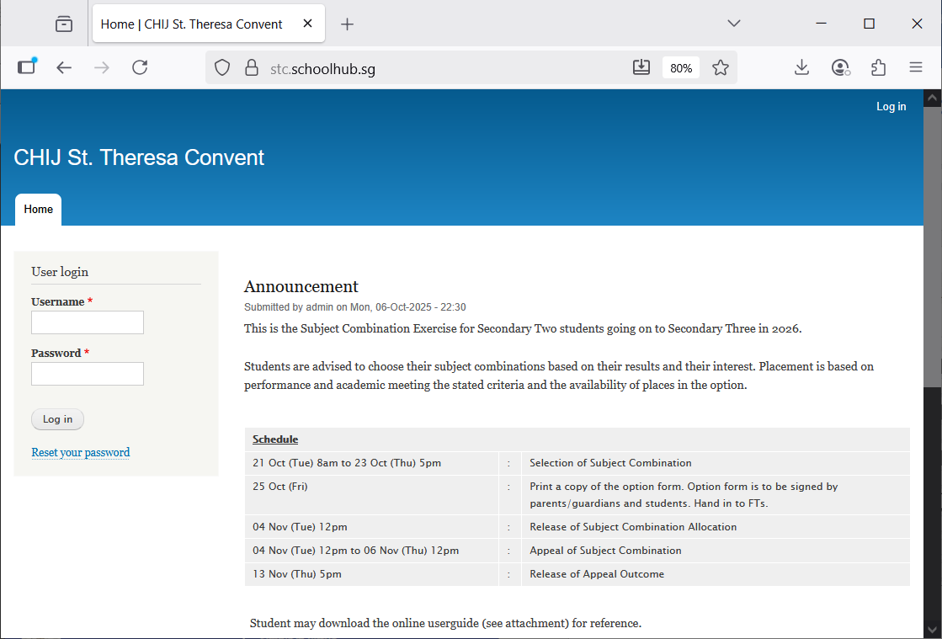

Steps
- Enter Username
- Enter Password
- Click Login

Register Choices

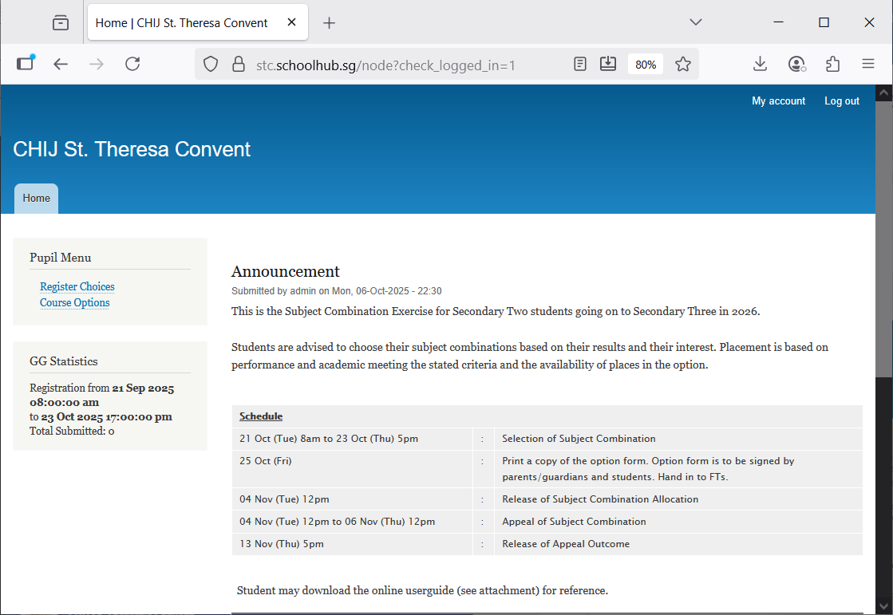

Steps
- Click Register Choices

The subjects are divided into different categories:
- EL - Compulsory
- MT - Compulsory
- MATH - Compulsory
- C/HUMANITIES
- SCIENCE
- OTHERS
You will need to rank all the subjects within each category. Please note that only subjects offered to you will be available for you to rank. For categories with only ONE Subject (Compulsory), it will be automatically rank 1.

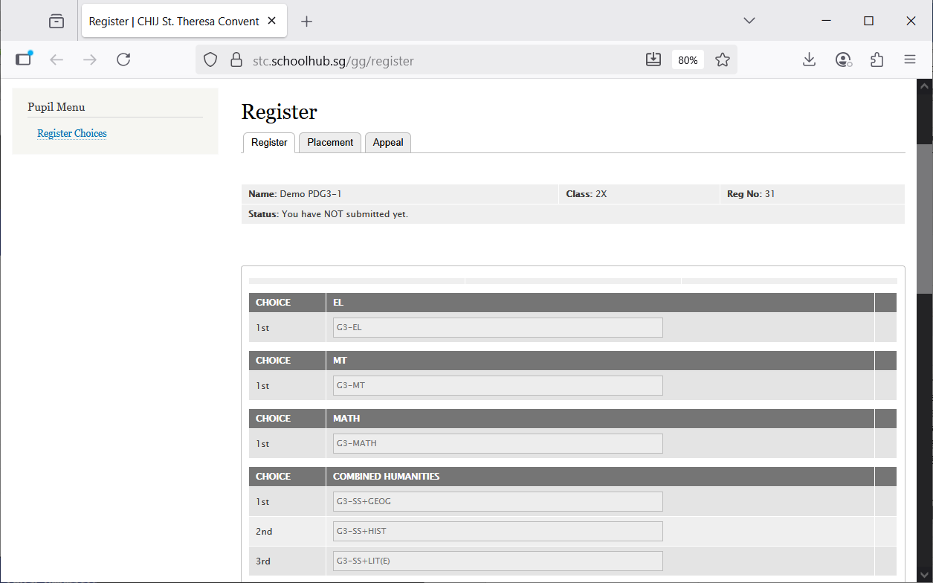
Hold and Drag to change your choices.
for example:
Change G3-SS-Hist to 1st choice
Change G3-SS+Geog to 2nd Choice
1st Choice = G3-SS+HIST
2nd Choice = G3-SS+GEOG
After changes:

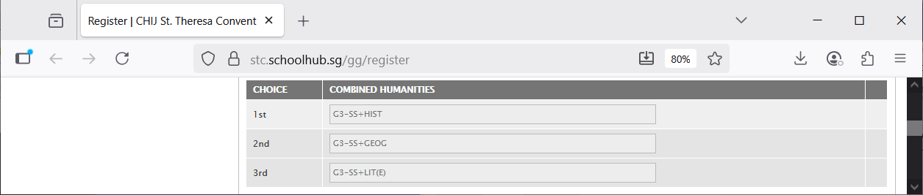

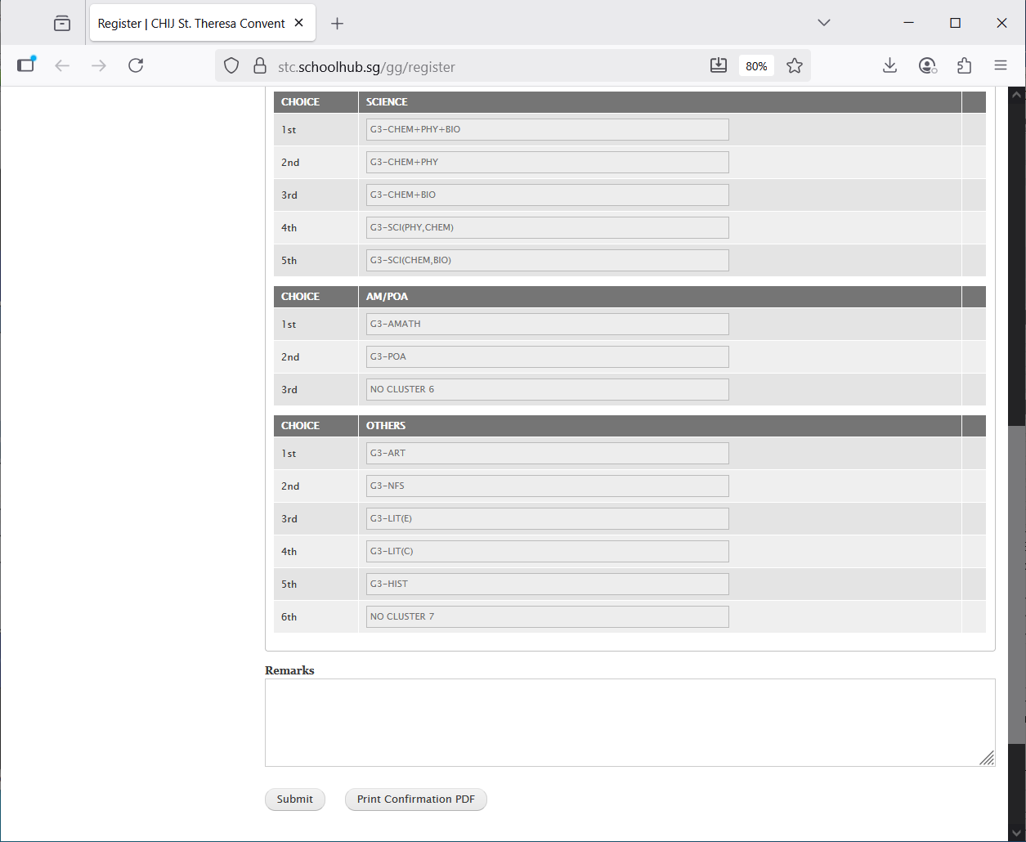
Enter any remark you wish to communicate with your teacher
Click Print Confirmation PDF to get a copy of the PDF for your reference.
Click Submit to save your choices. You may change them before the closing date.

Sample Confirmation Slip
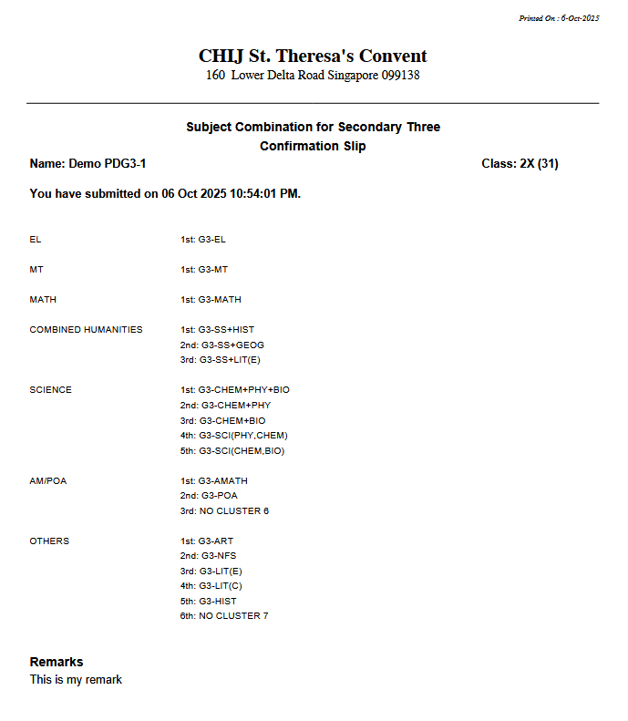

Check Subject Allocation (Placement)

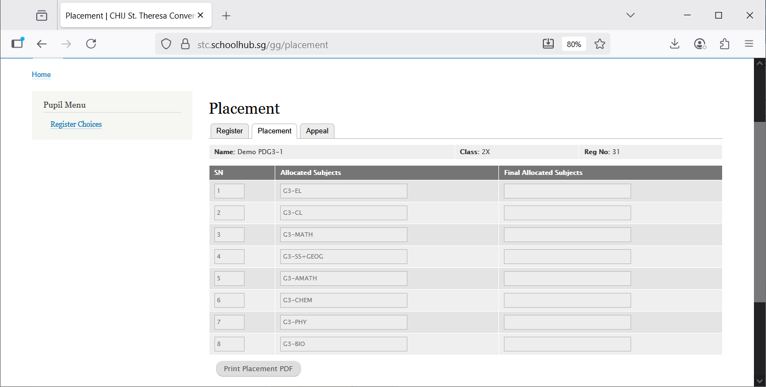
You may print a copy for your reference

Appeals

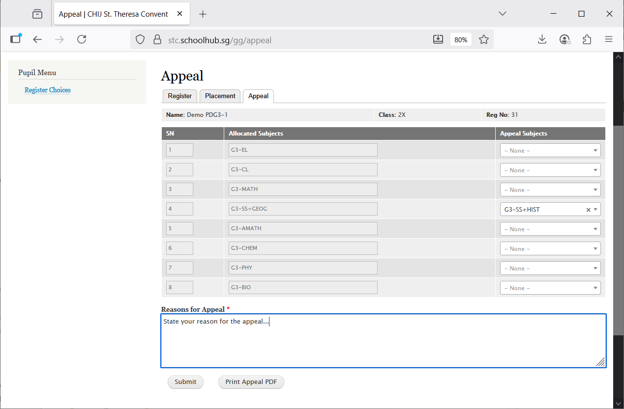
Indicate reasons for the Appeal
You may print a copy for your reference
Subject to Appeal for to replace G3-SS+GEOG

Check Final Subject Allocation

If there is no APPEAL, the Final Allocated Subjects will be the same as the Original Allocated Subjects.

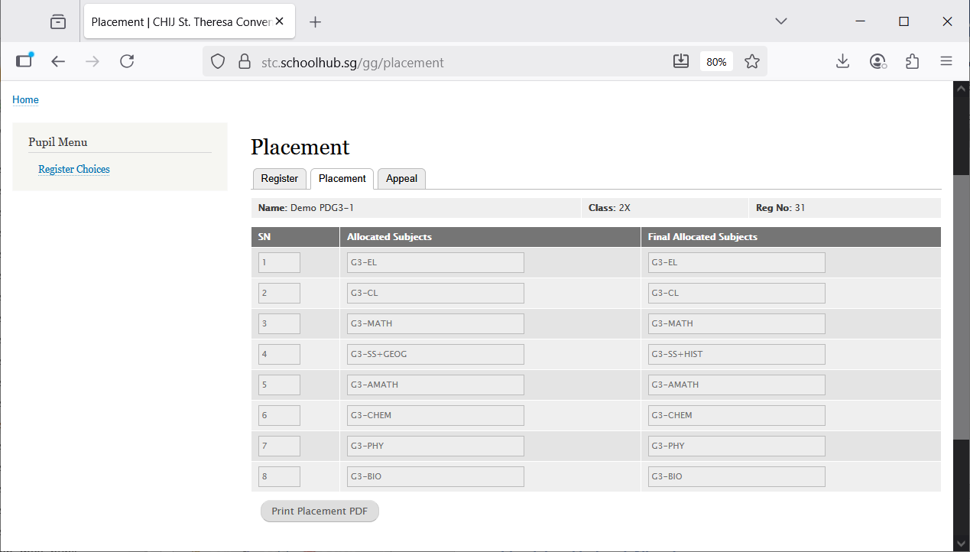
You may print a copy for your reference
Original Allocated Subjects
Final Allocated Subjects

