

**CHIJ St. THERESA’S SCHOOL**

**SUBJECT OPTIONS**

**STUDENT PORTAL**

**User Guide for Students**

Contents

Website 2

Main Screen 2

My Account 4

Subject Combinations 5

Update Choices and Subject Preferences 6

Submission of Choices and Subject Preferences 8

Sample Confirmation Slip 9

# Website

The URL for the Subject Options Student Portal is <https://stc.schoolhub.sg/>

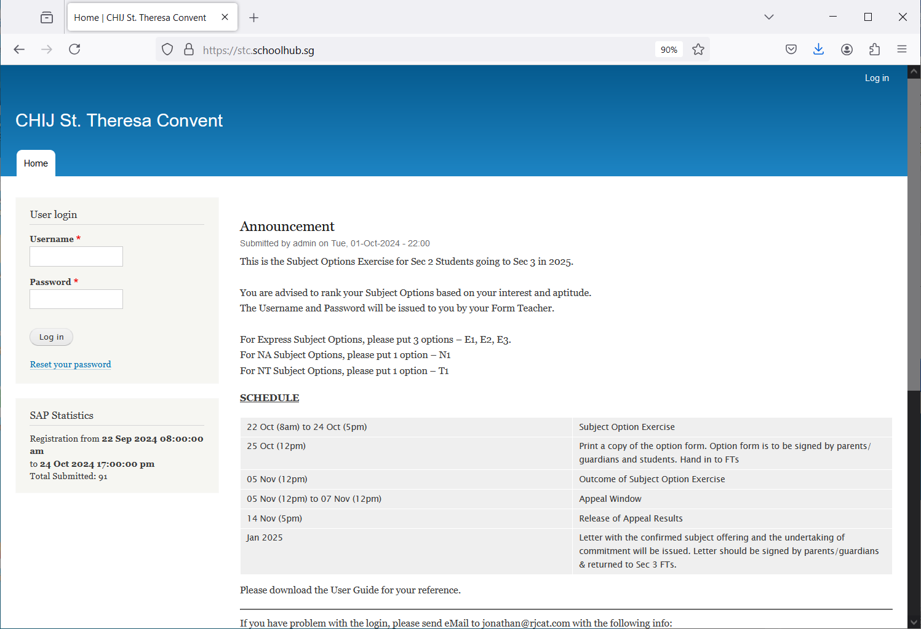

Your Password

Your Username

STEPS

* Enter Username
* Enter Password
* Click on the Login button

Note  
Students are encouraged to change your password immediately after the first login (see page 4).

Remember your password especially after you have changed it as you would need to use it more than once.

# Main Screen

Upon successful login, you will see the Main Screen.

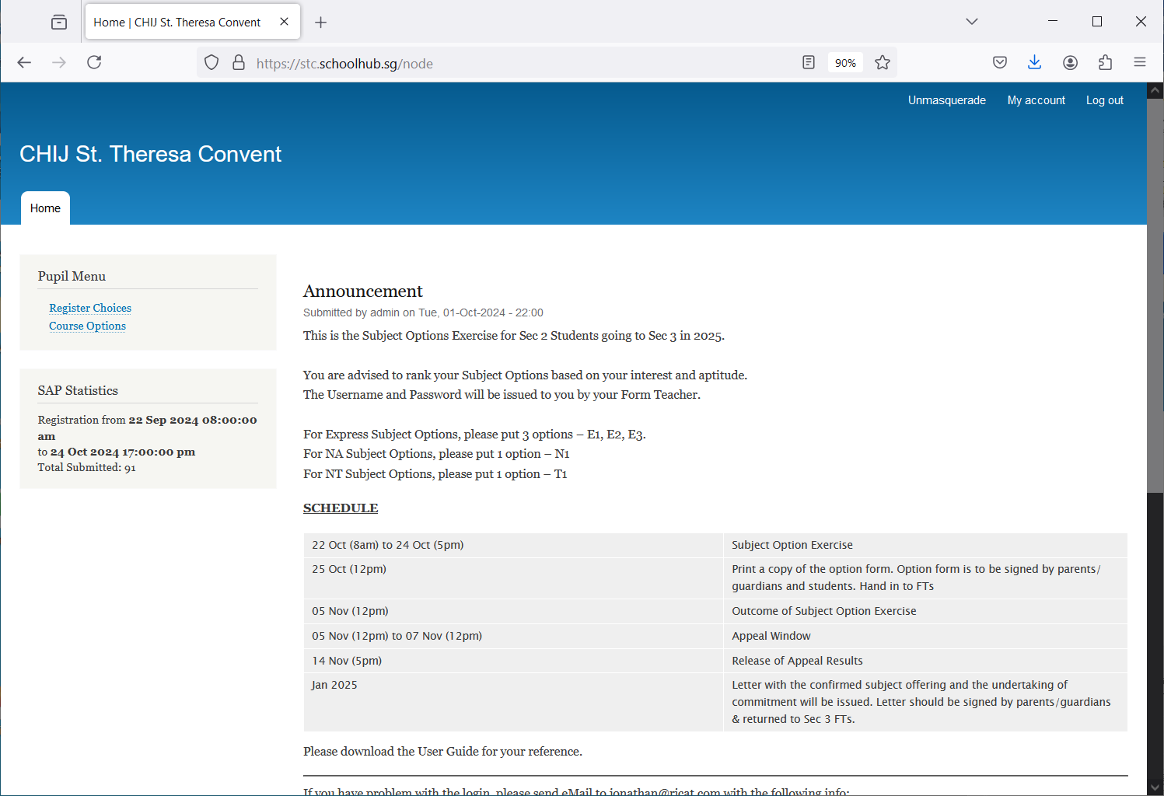

Lookout for Latest News & Announcements

If you need to change your password

Click “Course Options” to view the different options

Click “Register Choice” to begin selecting your subject options

# My Account

You may change your password and update your email address.

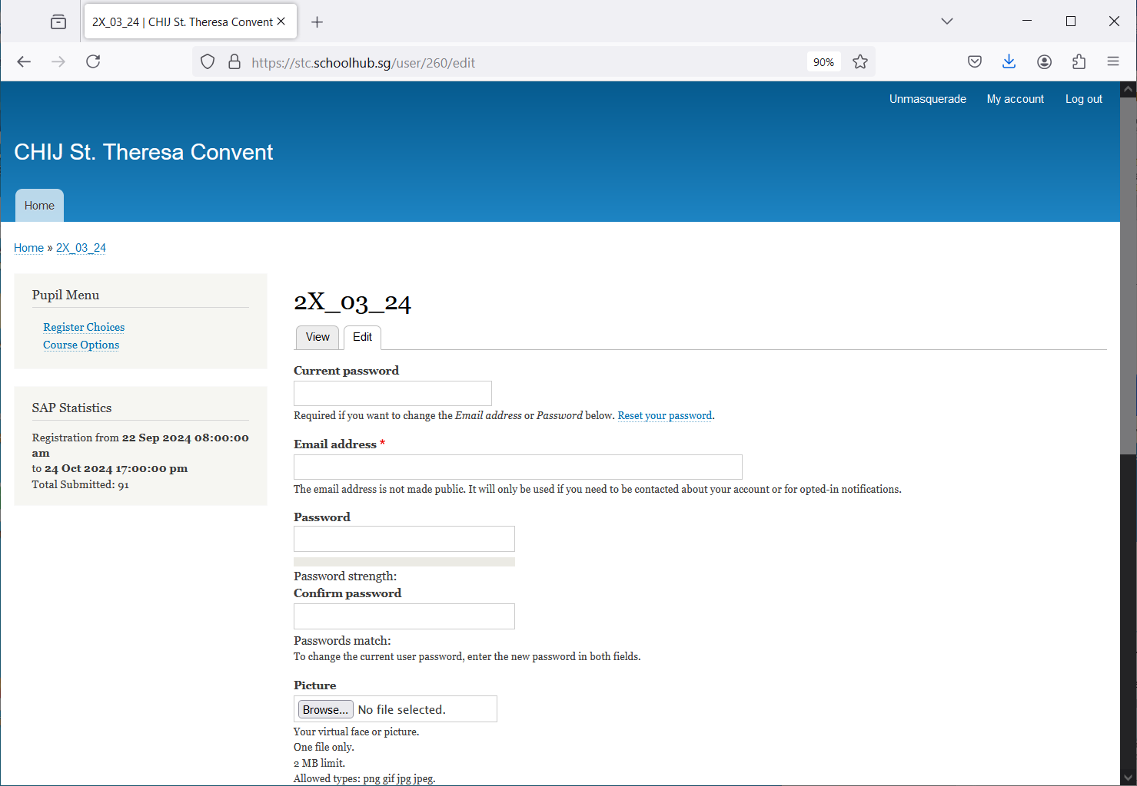

Please enter a valid email address. With this email address, you can retrieve your password via “Request New Password” link on the Home page if you have forgotten your password.

STEPS

* Enter current password
* Enter email address
* Enter new password
* Enter confirm password
* Click on the Save button (at the bottom of the screen)

# Subject Combinations

The page shows the different Subject Options you may choose from.

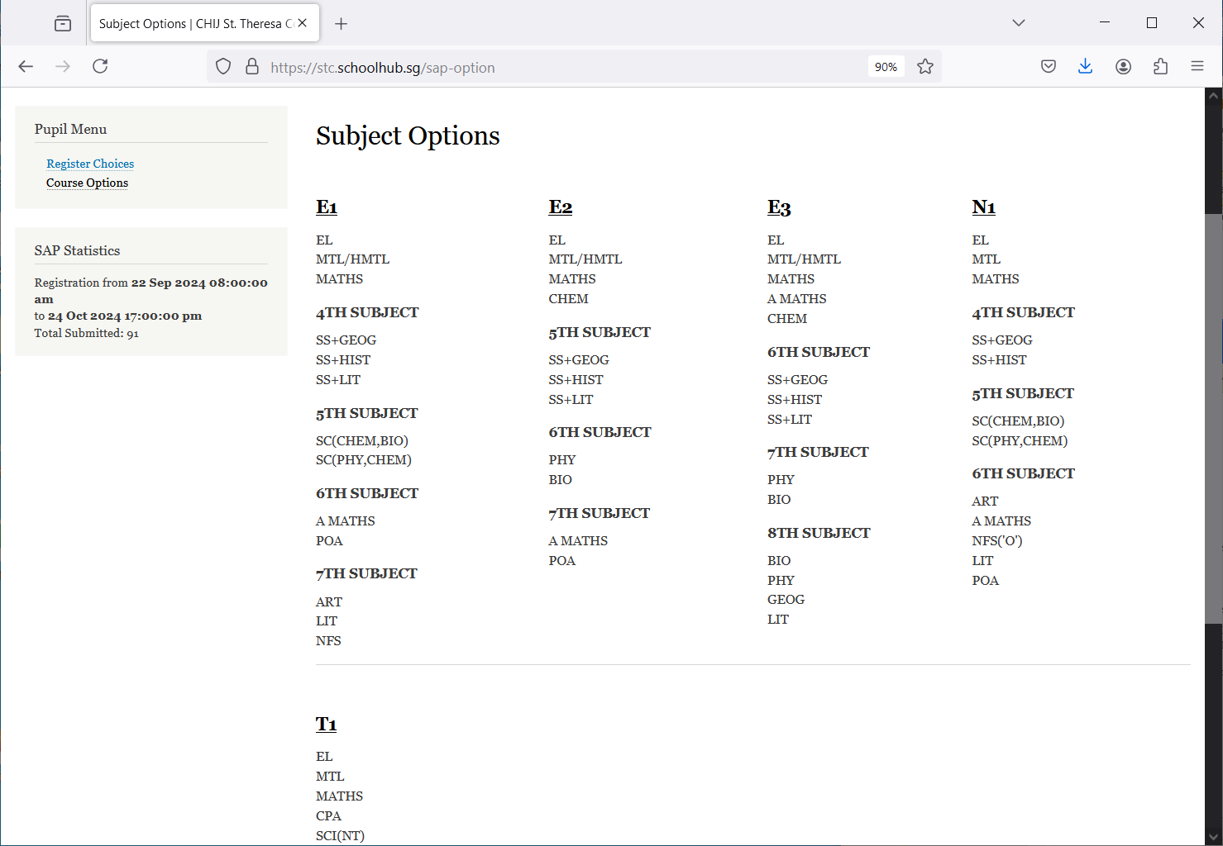

# Update Choices and Subject Preferences

Order of Preference for Options

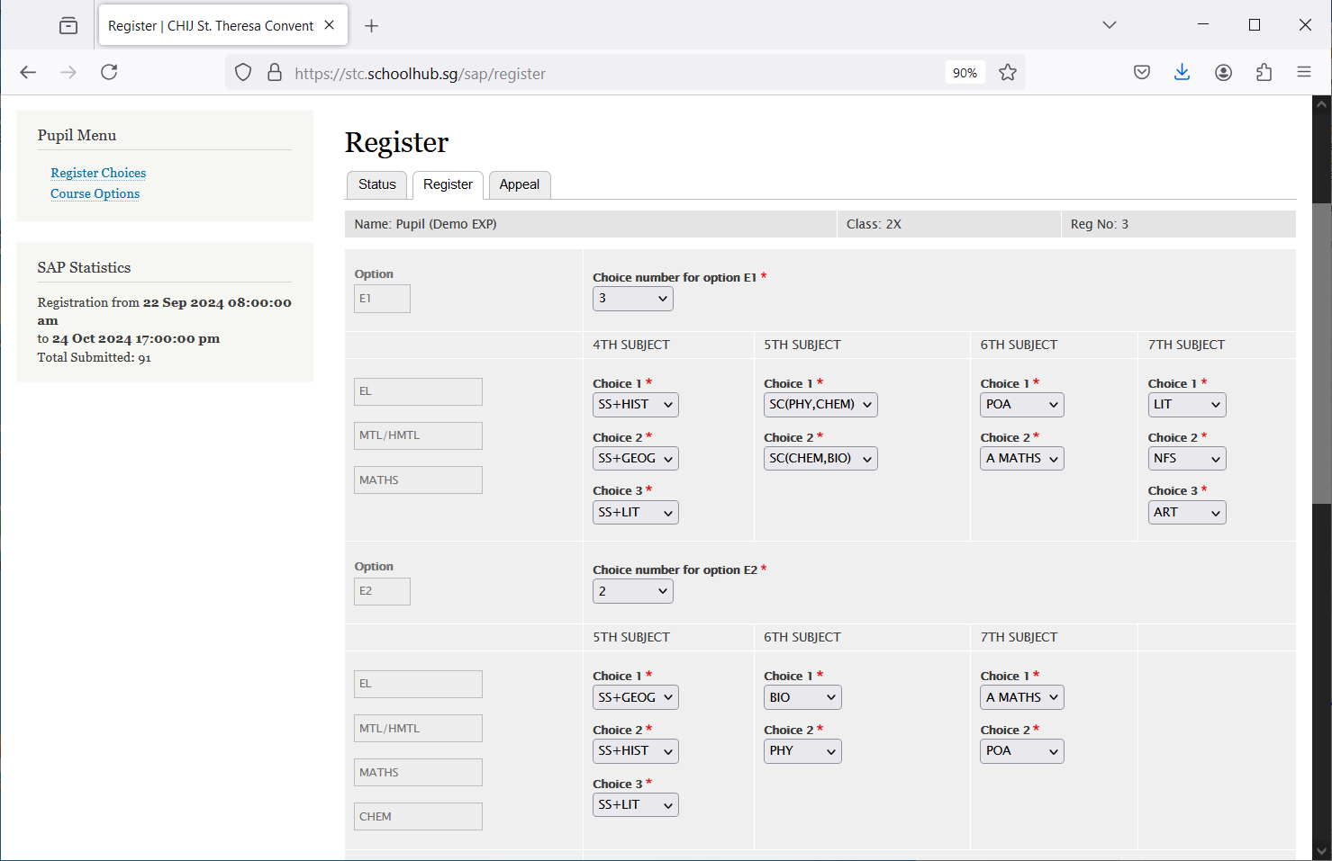

Order of Preference for Subjects with Choices  
(Do not enter the same subject more than once)

Mandatory Subjects of the Option

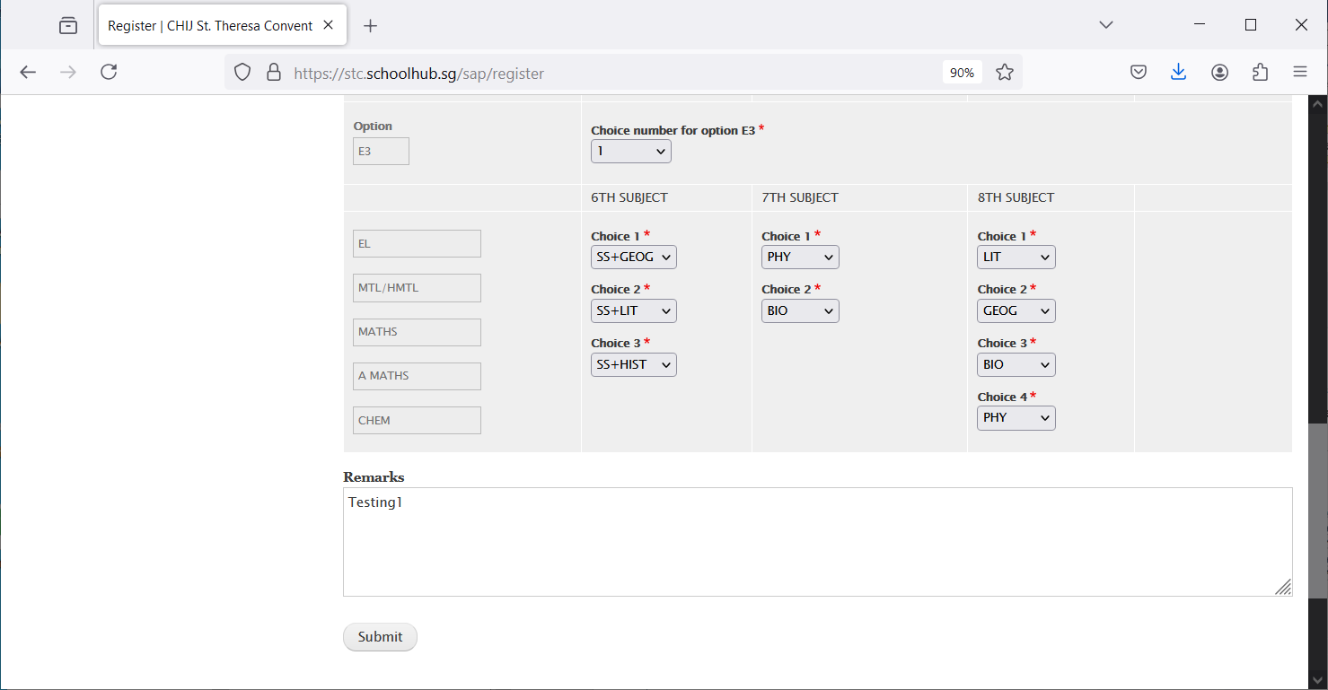

Enter your remark, if any

STEPS

* Enter your Choice for each Option, i.e. choice 1, 2 or 3 (see step 1 in the diagram)
* For Subjects with choices, i.e. the 5th, 6th etc, rank all the subjects in each group, where 1 indicates your first choice (see step 2 in the diagram)
* Click on the Submit button

Note  
You may change your Choice and rank order of the subjects anytime before the closing date. Where there are more than one submission, only the last submission will be considered.

## Submission of Choices and Subject Preferences

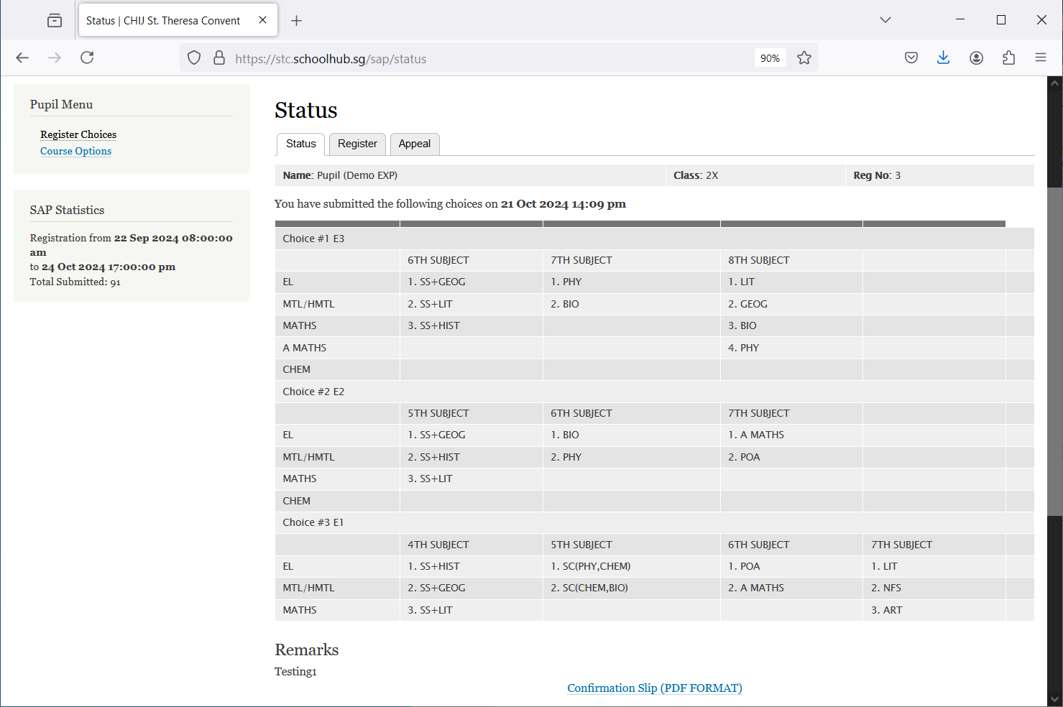

Print Confirmation Slip

## Sample Confirmation Slip

